SPONSORSHIP COMMITMENT

[ ] Vegas Sponsor $1,500 [ ] Royal Straight Flush Sponsor $1,200 [ ] 4-of-A-Kind Sponsor $1,000 [ ] Full House Sponsor $750
[ ] AYTEF Sponsor $600 [ ] Individual Ticket $100 [ ] Silent Auction/Raffle Item/Misc.

Description of donation: _________

Contact Information

PERSON/ORGANIZATION (AS IT SHOULD APPEAR IN PRINTED MATERIAL)

STREET ADDRESS

CITY STATE ZIP

TELEPHONE EMAIL

For more information or to buy tickets visit aytef.org
Email: Ines Schmook – ines@ustaatlanta.com

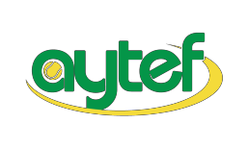
Atlanta Youth Tennis and Education Foundation

1
200 Ashwood Parkway | Suite 500 | Atlanta, Georgia 30338
Aytef.org | Facebook @aytefkids | Instagram @aytef

